

Power bi reporting

Author: Tyler Lu

Contents

1. Prerequisites 2

2. Create App WorkSpace 2

3. Create Power BI Report 3

4. Create Relationships 9

5. Create Report 10

Filters 10

Reason Graph 12

Issue Graph 14

6. Upload to AppWork Space and embed into Teams 16

7. Add Power BI Tab to teams 17

# Prerequisites

Ensure all users who need access to the PowerBI report have a PowerBI Pro license.

Download [PowerBI Desktop](https://powerbi.microsoft.com/en-us/desktop/)

# Create App WorkSpace

1. Log into <https://app.powerbi.com/>
2. Click **Workspaces** -> **Create App Workspace**

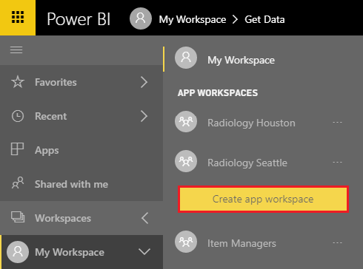

1. Give your App Workspace a name: **Huddle Pilot**

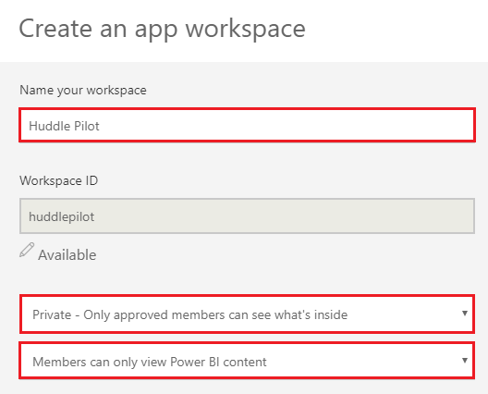

* Choose **Private – Only approved members can see what’s inside**
* Choose **Members can only view Power BI content**
* Add workspace members: add all members of the pilot who have a power bi license.

Click **Save**.

# Create Power BI Report

1. Open Power BI Desktop.
2. Click **Get Data** - > **More**

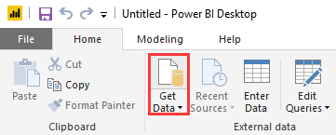

1. Select **Online Services** -> **SharePoint Online List**

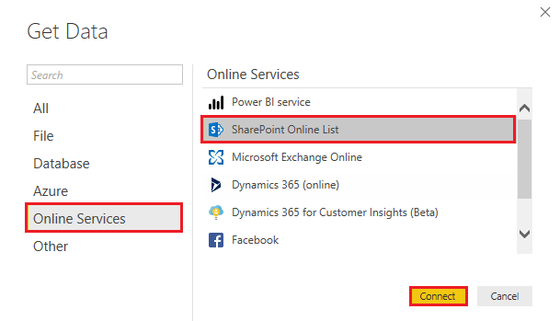

1. Enter in the URL of the site where the SharePoint lists are located

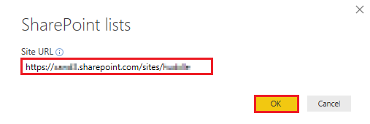

Click **OK**.

1. Sign in with the Huddle Microsoft account.

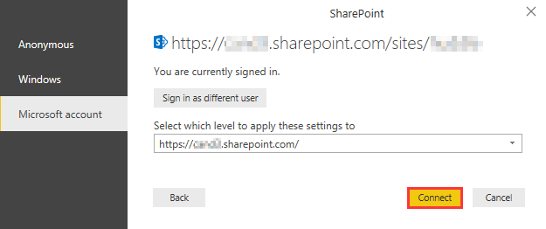

1. Select the following lists
   * Categories
   * Issues
   * Issue Metrics
   * Metric Ideas
   * Reasons
   * Reason Metrics

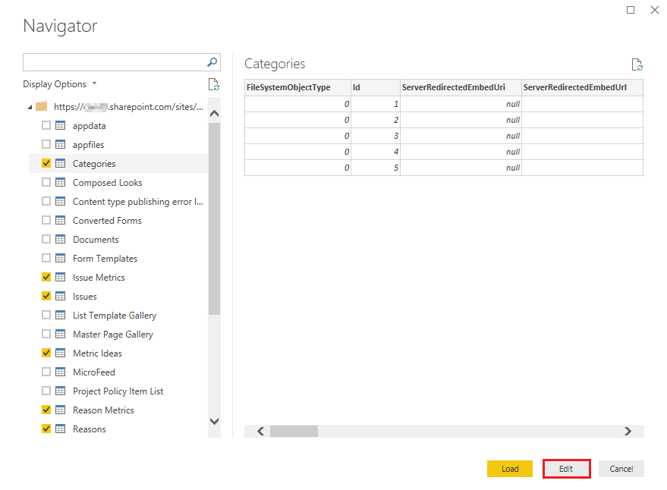

1. Click on the Edit button

For each query on the left keep only the columns identified in each table.

For each column change the data type if identify to. In order to change a data type right click on the column header in the queries vie

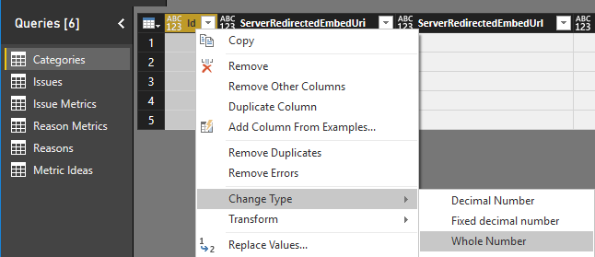

|  |  |  |  |
| --- | --- | --- | --- |
| Lists | Column | Change to Data Type |  |
| Categories | Id | Whole Number |  |
|  | Title |  | No Change |
|  | Modified | Date/Time |  |
|  | Created | Date/Time |  |
| Issues | Id | Whole Number |  |
|  | Title |  | No Change |
|  | Issue Metric |  | No Change |
|  | State | Whole Number |  |
|  | Team Id |  | No Change |
|  | Issue CategoryId | Whole Number |  |
|  | Target Goal | Whole Number |  |
|  | Modified | Date/Time |  |
|  | Created | Date/Time |  |
| Issue Metrics | Id | Whole Number |  |
|  | Title |  | No Change |
|  | Metric Value | Whole Number |  |
|  | IssueId | Whole Number |  |
|  | Input Date | Date |  |
|  | Modified | Date/Time |  |
|  | Created | Date/Time |  |
| Metric Ideas | Id | Whole Number |  |
|  | Title |  | No Change |
|  | MetricId | Whole Number |  |
|  | Task Id |  | No Change |
|  | Task URL |  | No Change |
|  | Task Name |  | No Change |
|  | Input Date | Date/Time |  |
|  | Current Status |  | No Change |
|  | Task Start Date | Date/Time |  |
|  | Task Completed Date | Date/Time |  |
|  | Modified | Date/Time |  |
|  | Created | Date/Time |  |
| Reasons | ID | Whole Number |  |
|  | Title |  | No Change |
|  | State | Whole Number |  |
|  | IssueId | Whole Number |  |
|  | Modified | Date/Time |  |
|  | Created | Date/Time |  |
| Reason Metrics | ID | Whole Number |  |
|  | Title |  | No Change |
|  | Reason Metric Value | Whole Number |  |
|  | ReasonId | Whole Number |  |
|  | Input Date | Date/Time |  |
|  | Modified | Date/Time |  |
|  | Created | Date/Time |  |

1. Once the queries have been updated click **Close & Apply**.

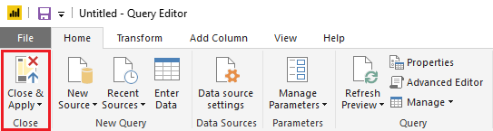

# Create Relationships

1. Click **Manage Relationships**

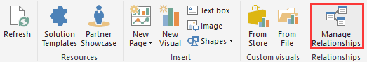

1. Click New and make the following relationships

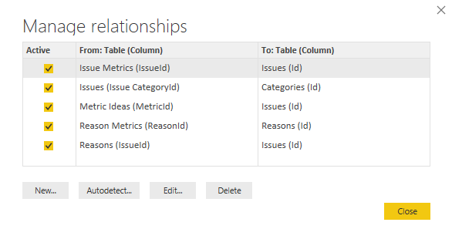

|  |  |  |  |  |  |
| --- | --- | --- | --- | --- | --- |
| Table | Column | Table | Column | Cardinality | Cross Filter direction |
| Issue Metric | IssueId | Issues | Id | Many to one | Single |
| Issues | Issue CategoryId | Categories | Id | Many to one | Single |
| Metric Ideas | MetricId | Issues | Id | Many to one | Single |
| ReasonMetrics | ReasonId | Reason | Id | Many to one | Single |
| Reason | IssueId | Issues | Id | Many to one | Single |

# Create Report

## Filters

1. Add 4 Filters to the top of the report left to right, each with the following tablet->column
   1. Categories -> Title
   2. Issues -> Title
   3. Reason - > Title
   4. Issues -> Team ID
2. Select each filter and change the name from Title to the appropriate name left to right.
   1. Pillar
   2. Issue
   3. Reason
   4. Team

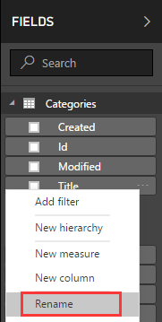

Filtering should look like this on the top of the report

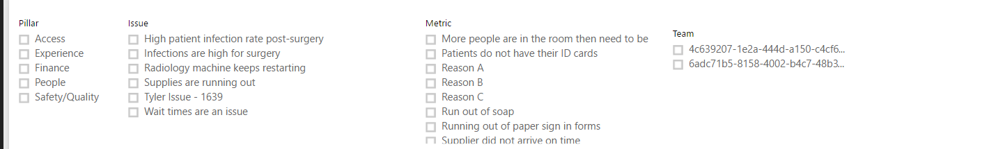

1. Select the background of the report page.
2. Drag **Issues**-> **State** to the **Report level filters**

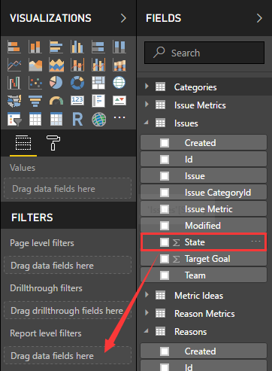

1. Change **Filter Type** to **Basic filtering**, then check **1**

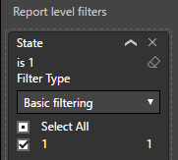

Save the report

## Reason Graph

1. Add a line chart to the report

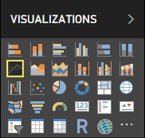

Make the graph full width the lower 3rd of the page.

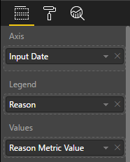

|  |  |  |
| --- | --- | --- |
| Graph | Table | Column |
| Axis | Reason Metrics | Input Date |
| Legend | Reasons | ~~Metric~~ Reason |
| Values | Reason Metrics | Reason Metric Value |

1. Click the down arrow on the axis section

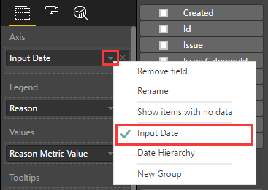

Change from Date Hierarchy to **Input Date**

## Issue Graph

1. Download Power KPI custom visual.

Click ᛫ ᛫ ᛫ -> **Import from store**

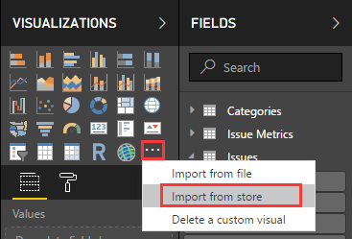

Select input from store

1. Search for **Power KPI**

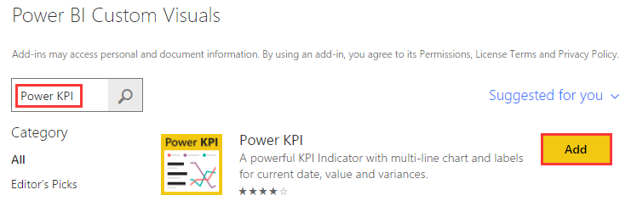

Click Add

1. Add the custom visual to the reports

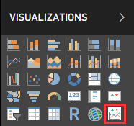

1. Stretch graph full width and put between reasons graph and filters
2. Modify the graph with the following settings

|  |  |  |
| --- | --- | --- |
| Graph | Table | Column |
| Axis | Issue Metrics | Input Date |
| Values | Issue Metrics | Metric Value |
| Issues | Target Goal |

Should look as follows when done

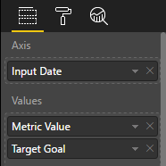

1. Select down arrow on Input Date and select InputDate

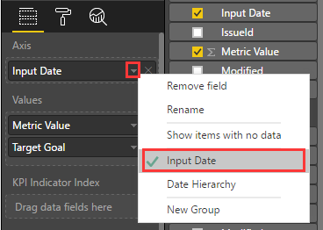

**Note at this point other cosmetic work can be done to the reports themselves.**

# Upload to AppWork Space and embed into Teams

1. Click **Publish**.

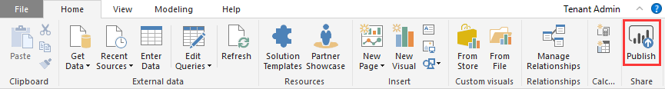

1. Deploy to the app group you created in Create App Workspace section.

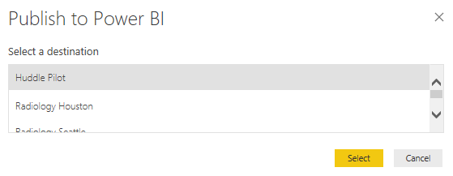

# Add Power BI Tab to teams

1. Click a team in Microsoft Teams



1. Click **+**, then click **Power BI**.

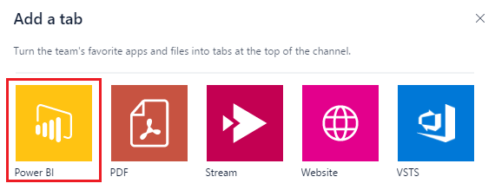

1. Select the app workspace you have created

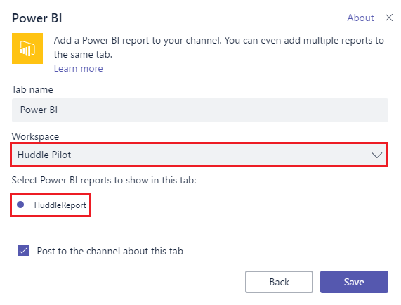

Then select the report.

1. Click **Save**. Report should now be embedded into Teams